

|  |
| --- |
| Canadian Labelling Laws:  *A resource guide developed by*  *LAT Multilingual* |
|  |
| Last updated: June 2020 |  |

## Table of Contents

Table of Contents i

Introduction 2

Canadian Labelling Law 3

Non-Food products 3

Food Products 4

Bilingual Requirements 4

Québec’s French language requirements 4

## Introduction

In December 2016, the Government of Canada introduced a number of [changes](https://www.canada.ca/en/health-canada/services/food-labelling-changes.html) to the Food and Drug Regulations (FDR) intended to make nutrition information on food labels more useful to Canadians. The most notable amendments include new front-of-package (FOP) labelling requirements for products that contain threshold levels of certain nutrients such as sodium, saturated fats and sugars.

The changes have been put in place for four main reasons. They are intended to:

1. Reduce sodium in processed foods;
2. Eliminate industrially-produced trans-fat;
3. Provide consumers with more information about sugars and food colours; and
4. Introduce restrictions on the commercial marketing of unhealthy foods and beverages to children.

A five-year transition period was established for industry to meet the new requirements. The food and beverage industry has until December 2021 to change labels and packaging.

This guide presents an overview of these changes, while providing a general outline of Canadian labelling legislation. Labels and their ingredients’ list are subject to many requirements spanning beyond the scope of this simplified guide. Although most requirements stated come from the Canadian legislations, some requirements also come from other sources, such as the Canadian Food Inspection Agency (CFIA).

**Please note:** LAT Multilingual has prepared this documentation in an effort to help you navigate the complexities of this ever-changing landscape. LAT cannot assume responsibility for problems, errors or ommissions arising from using this guide.

## 

## Canadian Labelling Law

## Non-Food Products

Labels on non-food products must display the following three items:

**1) Product Identity**

**2) Product Net Quantity**   
  
The net quantity should be:

* in metric units of volume, when the product is a liquid, a gas, or is viscous;
* in metric units of weight, when the product is solid;
* by numerical count when the product is sold by individual units.
* The numerical portion of the net quantity declaration must be in bold There are also minimum type heights depending on the size of your principal display surface (see table below)

**3) Dealers Name and Principal Place of Business**

If you are importing a prepackaged product that has been manufactured or produced in a country other than Canada, you must include the name and address of a Canadian dealer preceded by the words "imported by/importé par" or "imported for/importé pour" or the name and address of the dealer outside Canada.

**Type Height**

The numerical portion of the net quantity declaration must have a type height not less than the minimum size outlined below:

|  |  |
| --- | --- |
| **Area of Principal Display Surface\*** | **Minimum Type Height** |
| Not more than 32 cm2 (5 in2) | 1.6 mm (1/16 inch) |
| More than 32 cm2 (5 in2) but not more than 258 cm2 (40 in2) | 3.2 mm (1/8 inch) |
| More than 258 cm2 (100 in2) but not more than 25.8 cm2 (100 in2) | 6.4 mm (1/4 inch) |
| More than 645 cm2 (100 cm2) but not more than 25.8 cm2 (400 in2) | 9.5 mm (3/8 inch) |
| More than 25.8 cm2 (400 in2) | 12.7 mm |

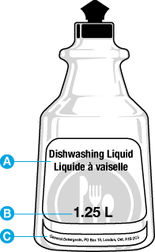

**Example of Liquid and Viscous Packaging with Mandatory Label Information:**

1. Product Identify Declaration
2. Product Net Quantity Declaration
3. Dealer Name and Principal Place of Business

## Food Products

Labels on food products require the following:

* Common name
* Net quantity declaration
* Dealer name and address (same regulations as for non-food items)
* List of ingredients (including food allergens)
* Durable life date
* Nutrition Facts table (see below)

By law, the nutrition facts table gives information on:

* Serving size
* Calories
* Nutrients
* Percent daily values (% DV)
* Ingredients list, which lists all the ingredients in a food by weight (this begins with the ingredient that weighs the most and ends with the ingredient that weighs the least)

Don’t forget, if you make a claim on your package such as “high in calcium”, you must list the amount of the vitamin/mineral that is present in the nutrition facts table to back up your claim.

## Bilingual Requirements

All mandatory information must be in both official languages of Canada: **English and French.**

* Numbers are considered bilingual
* Measurements must be converted to the metric system.

There are a few cases in which you do not need bilingual labelling:

* The identity and principal place of business can be in either English or French.
* Shipping containers that are not sold to consumers.
* Local products (defined as food that is sold only in the local government unit in which it is manufactured, processed or packaged and in a local area in which English or French is the mother tongue for less than 10% of the residents).
* Official test market products (temporary exemption).
* Specialty foods (e.g., foods that have special religious significance, and are used in religious ceremonies).
* Products in which knowledge of the language is essential to its use (for example: books or greeting cards) can appear in the appropriate language (This applies to non-food products only).
* Information outside of the must-haves. For example: slogans or usage directions do not have to be bilingual (but it is encouraged).

**Important note:** With all of these labels there are very strict stipulations regarding font size, height, use of bold and spaces.

## Québec’s French language requirements

If you’re taking the trouble to adapt your labels to meet the Canadian market requirements, you may want to make sure you also meet Quebec’s language requirements. The latter are a bit stricter, but going this extra mile will be well worth it. Quebec represents a market of over 7 million customers who are known for their epicurean life style and brand allegiance. If your brand succeeds in conquering the heart of customers in Quebec, your efforts will be well rewarded.

The Charter of the French Language, also known as Loi 101, enforces strict rules about the use of various languages within Quebec’s borders.

French must be included on all forms of labels and communication. This includes:

* All product labels, containers, and accompanying documents (e.g., warranty, directions, etc.) (If there are multiple languages on a product label, French must have “greater prominence” than the other languages)
* Menus and wine lists
* Marketing materials (e.g., catalogues, brochures, folders, commercial directories etc.)
* Computer software (including game software and operating systems)
* Contracts
* Employment application forms, order forms, invoices, receipts, etc.
* Public signage, posters, and commercial advertising
* Brand names
* Toys or games that require the use of non-French vocabulary for their use are forbidden unless there is an equivalent French product available on the Quebec market (Charter of the French Language, Section 54)

Labelling Amendments: What’s Changing?

Various changes in the labelling amendments apply to food products:

* Nutrition facts table
* List of ingredients
* Serving size
* Sugars information
* Health claims

Nutrition Facts Table

The changes to the **nutrition facts table** include:

* Making the serving size more consistent, so that it’s easier to compare similar foods.
* Increasing the font size of serving size and calories and adding a bold line under the calories.
* Adding potassium. The amounts in milligrams (mg) for potassium, calcium and iron will need to be displayed.
* Removing vitamins A and C.
* 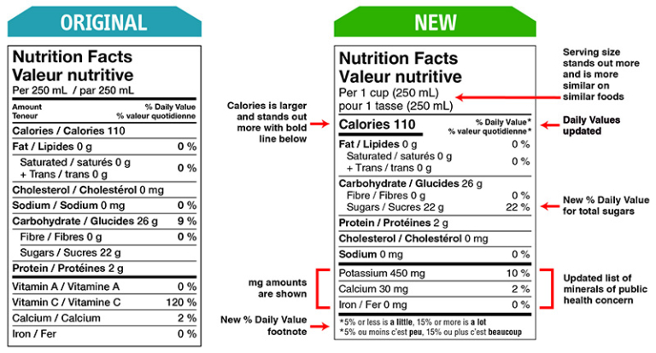Adding a footnote at the bottom of the table about % daily value to help consumers understand how much sugar and other nutrients (like sodium) are in their food and will explain that 5% or less is a little and 15% or more is a lot. This change will help Canadians to better compare two food products (formatting specifics for this area will be “a little”, “a lot”, “peu” and “beaucoup” in bold).

List of Ingredients

The changes to the list of ingredients include:

* Grouping sugars-based ingredients in brackets after the name ‘sugars’ to help consumers.
* Identifing all of the sources of sugars added to a food.
* Listing food colours by their individual common names rather than the generic term “colour”.
* Making the text in black font on white or neutral background.
* Creating minimum type height requirements for ingredients.
* Using bullets or commas to separate ingredients.
* Using both upper and lower-case letters for the ingredients in the list.

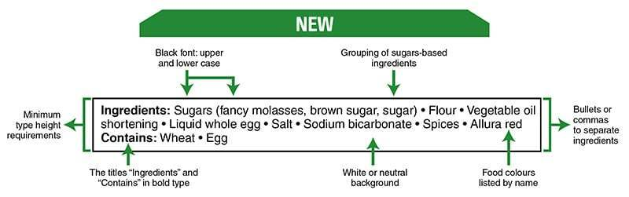  
The same format rules will apply to any ‘contains’ statement indicating the presence or potential

presence of:

* Priority food allergens (see [list of food allergens required to be declared in Canada](https://www.inspection.gc.ca/food-label-requirements/labelling/industry/list-of-ingredients-and-allergens/eng/1383612857522/1383612932341?chap=7#s13c7))
* Gluten sources
* Added sulphites

These changes will make it easier to find, read and understand the list of ingredients.

Serving Size

Changes to serving size will better reflect the amount that Canadians eat in one sitting. This is because serving sizes will be based on regulated reference amounts. Serving sizes will also be more consistent, making it easier to compare similar foods and know how many calories and nutrients are being consumed (the changes are different for single serve and multi-serving packages).

For **foods that can be measured**, like yogurt, the serving size will be shown as a common household measurement, such as:

* cup
* teaspoon
* tablespoon

For **foods that come in pieces or are divided**, the serving size will be show as either:

* the number of pieces or
* as a fraction of the food.

This will be paired with its weight in grams. Similar products will have the same or very similar gram amounts. For certain foods like sliced bread, the serving size will reflect the way they’re typically eaten, followed by its weight in grams. For example, the serving size on a bag of bread will show two slices of bread and its weight in grams. This reflects that most people eat two slices of bread at one time. This will make it easier for you to compare different types of bread.

Sugars Information

The changes to sugars include those in the nutrition facts table and list of ingredients.

A % daily value has been included for total sugars to help compare the sugars content of different foods and identify sugary foods that should be limited, such as those with a sugars daily value of 15% or more.

Sugars - List of ingredients

**Formatting changes**, include presenting the text of the list of ingredients in black font on a white or neutral background, providing minimum type height equirements for ingredients, using bullets or commas to separate ingredients, and using both upper and lower-case letters for ingredients in the list are all aimed at making the list of ingredients easier to find, read and understand.

The same formatting changes will also apply to any ‘contains’ statement within an ingredient list indicating the presence or potential presence of priority food allergens, gluten sources and added sulphites.

**Changes to the list of ingredients** include grouping sugars-based ingredients in brackets after the name ‘sugars’ to show all of the sources of sugars added to a food.

Sugars-based ingredients will be grouped in brackets in descending order by weight after the name ‘sugars’.

Sugars can include:

* white sugar
* beet sugar
* raw sugar or brown sugar
* agave syrup, honey, maple syrup, barley malt extract or fancy molasses
* fructose, glucose, glucose-fructose (also known as high fructose corn syrup), maltose, sucrose or dextrose
* fruit juice concentrates and purée concentrates that are added to replace sugars in foods.

Health claims

The amendments allow the claim that fruits and vegetables reduce the risk of heart disease, thereby allowing Canadians to be informed of the health benefits of eating fresh fruits and vegetables. The claim “A healthy diet rich in a variety of vegetables and fruit may help reduce the risk of heart disease” is allowed on fruits and vegetables.

Don’t forget to use the CFIA’s rather useful “[labelling checklist](https://www.inspection.gc.ca/food-label-requirements/labelling/industry/food-labelling-requirements-checklist/eng/1393275252175/1393275314581)” to make sure your label contains all the necessary information.

Translation: It Pays to Get it Right

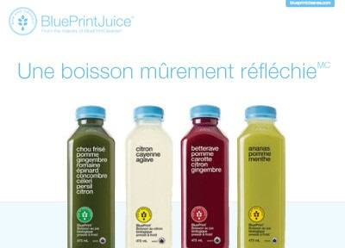Don’t just translate your content, adapt it to the local market. LAT Multilingual is experienced in bilingual packaging, having helped many food and beverage clients like McCormick, HAIN Celestial and Litehouse Inc. adapt their packaging to ensure they are well positioned within the Quebec market. This work includes necessary localization to ensure brand messaging and taglines speak to its intended audience. For example, when HAIN Celestial launched their new BluePrint Juice in Canada with the slogan “We Think. You Drink.” we needed to determine an equally well thought out tagline in French so that it resonated with the Quebec market. We came

up with “Une boisson mûrement réfléchie”.

Don’t risk a cultural misstep. When Pepsi had the slogan, “Come alive with the Pepsi Generation” translated into Taiwanese it became, “Pepsi will bring your ancestors back from the dead”. Avoid these mishaps by hiring trusting professionals who will review the content from a cultural perspective to ensure it is factually accurate and culturally correct.

Have questions? We’re here to help. Feel free to call us at 1 866 936 3833 or email [contactus@latmultilingual.com](mailto:contactus@latmultilingual.com).

|  |  |  |
| --- | --- | --- |
|  | | |
|  |  | | |
|  |  | | |
| **Vancouver**  200-1892 West Broadway  Vancouver, BC V6J 1YN  **Montreal**  407 McGill Road, Suite 700 Montreal, Quebec H2Y 2G3  1 866 936 3833 | contactus@latmultilingual.com  **www.latmultilingual.com**  **Mon**  **Vancovuer www.latmultilingual.com** | |  | | |
|  |  | | |
| **Mon** |  | | |